Government Engineering College, Bhavnagar
Report for SSIP 2.0 Awareness Programme
Name of Department | Electronics and Communication Engineering
Target Audience | Branch: Electronics and Communication Engineering  Sem: 4
Venue:  Date:  Time | Room no. 406, EC Building  23 June 2023  12:15
No. Participants | 47
Name of Expert and affiliation | Mansi Kothari, Pratik Gohel, Amit Rathod
Photographs of Programme
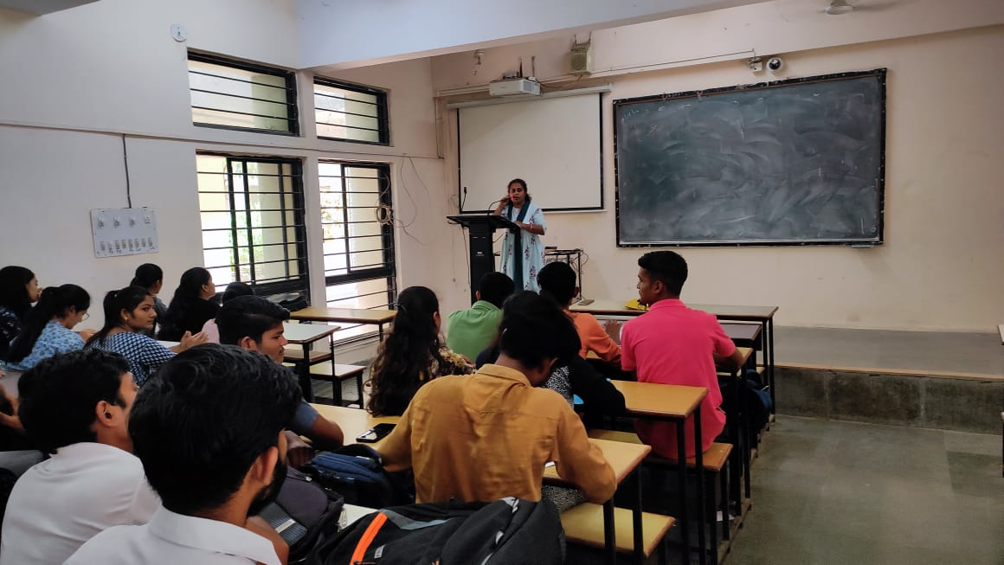 |  | 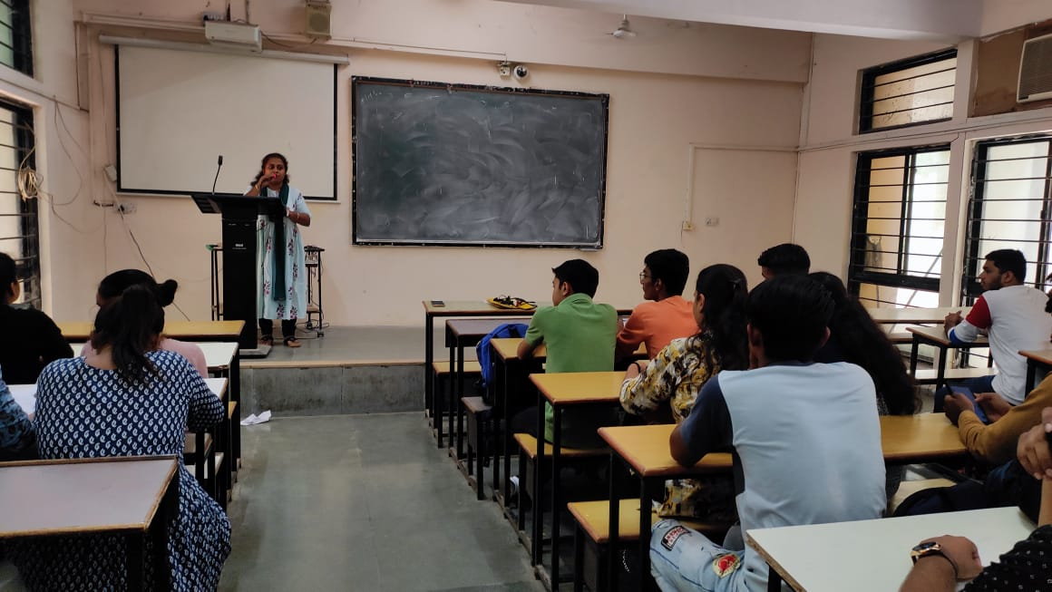
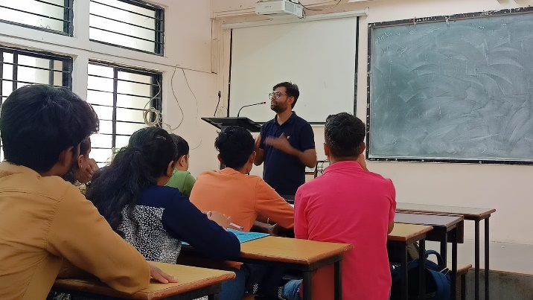 |  | 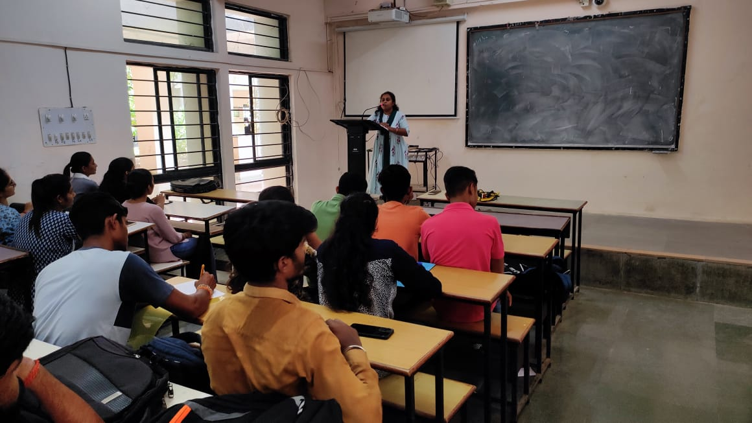
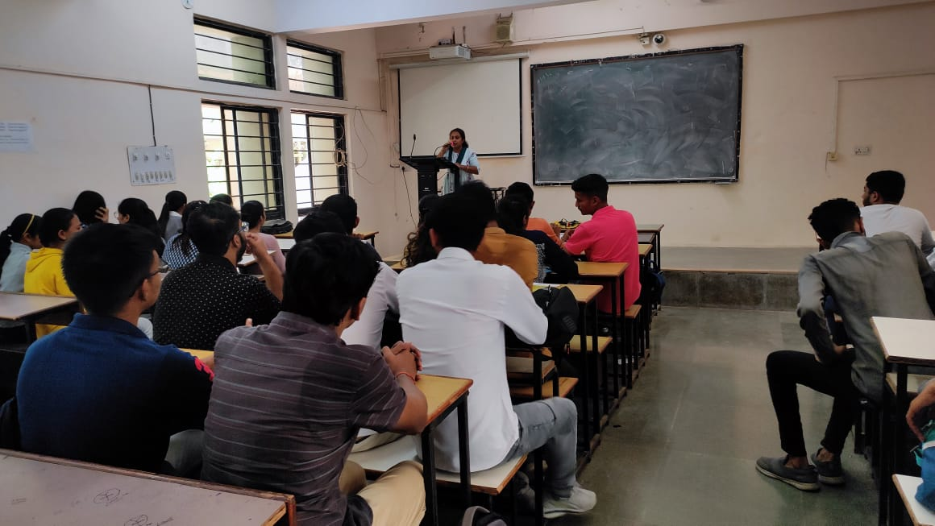 |  | 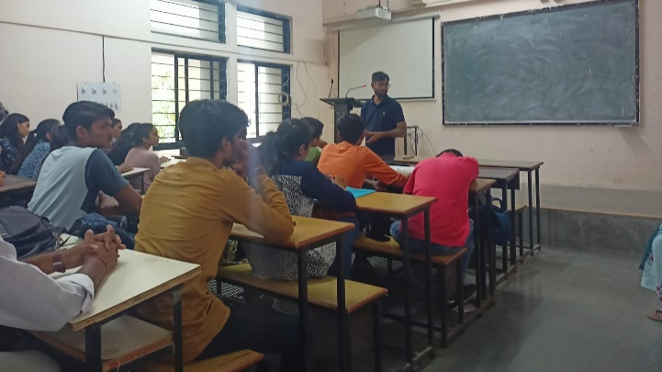

Feedback Form for SSIP 2.0 Awareness workshop

Strongly disagree Strongly agree

1 Content was presented clearly 1 2 3 4 5
and effectively

2 Was responsive to questions/comments 1 2 3 4 5

3 Teaching aids/audiovisuals were used effectively 1 2 3 4 5

4 Content met stated objectives 1 2 3 4 5

5 overall Programme was informative 1 2 3 4 5

